Elijah Andrushenko

CPTS 453

Graph Theory

09-25-2019

Homework #3

1.

$2\left|E\right|= \sum_{v∈V}{\deg\left(v\right)≤K}$

Then the maximum amount of leaves is K-1, So using contradiction we can show

$$\sum_{v∈V}{deg⁡(v)}= \sum_{v∈leaf}{1}+ \sum_{v∈nonleaf}{deg⁡(v)} ≤\left(k-1\right)+K\left(n-K+1\right)=2K-K^{2}+Kn-1$$

By definition the sum of all degrees in a tree is 2|E| = 2(n - 1) = 2n – 2 which leads to an inequality in regards to n.

2.A)

n = number of nonparents

Out of p parents, there exists one parent of degree $q, p-1$ parents have a degree of $q+1$.

Using the handshaking lemma, $q + (p-1)(q+1) + n =$ the number of edges

The number of edges = $p+n–1$.

$$q\left(p-1\right)\left(q+1\right)+n = 2p+2n-1$$

$$q+pq-p-q-1+n = 2p+2n-1$$

$$n = (q-1)(p+1)$$

B)

$$\left|V_{k+1}\right|≤q\left|V_{k}\right| ≤q*q\left|v_{k-1}\right|≤q*q*q\left|v_{k-2}\right|≤… ≤q^{k+1}|v_{0}|$$

$$\left|v_{k+1}\right| ≤q^{k+1}$$

$$\left|V_{k}\right|≤ q^{k}$$

C) For a binary tree with n vertices the minimum height will be log2(n)+1.

For a binary tree with 109 vertices the minimum height will be log2(109)+1.

For a 5-ary tree with 109 vertices the minimum height will be log5(109)+1.

log5(109)+1 = **13**

3.

The minimum possible height of 100 non parents in a full binary tree or 100! (100 factorial)?

If 100 just divide by 2 until you get to, or below 1.

(1) 100 / 2 = 50

(2) 50 / 2 = 25

(3) 25 / 2 = 12.5

(4) 12.5 / 2 = 6.25

(5) 6.25 / 2 = 3.125

(6) 3.125 / 2 = 1.5625

(7) 1.5625 / 2 = 0.78125

So the minimum possible height would be 7-1, we subtract one since the height of the root is 0.

**The minimum height is 6 for a full-binary tree with 100 non-parent nodes.**

If its 100 factorial then we have

100! = 9.332622e+157

(500) 9.332622e+157 / 2^500 = 28510564.9228

(520) 28510564.9228 / 2^20 = 27.1897935131

(523) 27.1897935131 / 2^3 = 3.39872418913

(524) 3.39872418913 / 2 = 1.69936209457

(525) 1.69936209457 / 2 = 0.84968104728

**The minimum height is 524 for a full-binary tree with 100! non-parent nodes.**

4.

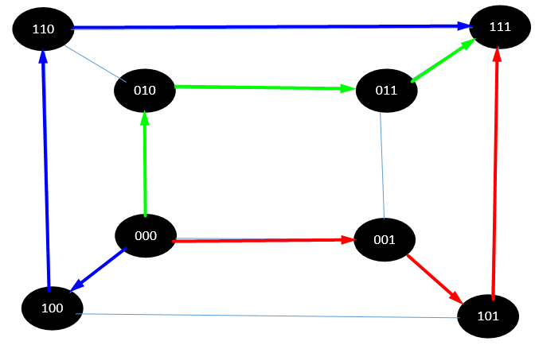[000]-[001]-[101]-[111]

[000]-[010]-[011]-[111]

[000]-[100]-[110]-[111]